Assignment 1: Kalman Filter

The objective of this assignment is to simulate a simple robot moving in a straight line using the classic Kalman Filter algorithm. The system was simulated using pygame.

Initial conditions are:

Other parameters are:

As shown in figure 1, the red lines are the 8 update iterations(prior, using the latest input), while the blue lines are the posterior(using the prior and correcting it with the measurement model). As expected, the higher variance in process noise and the lack of a correction step makes the prior trajectory deviate from the straight line path more than the posterior trajectory after correction step. The measurement noise has smaller variance, and it incorporates both a prior estimate and a measurement model, making the guess more accurate and closely approximating ground truth. The green covariance ellipse display how uncertainty in the trajectory is the smallest after each correction step, but gets larger as more prior estimates are made without any correction step.

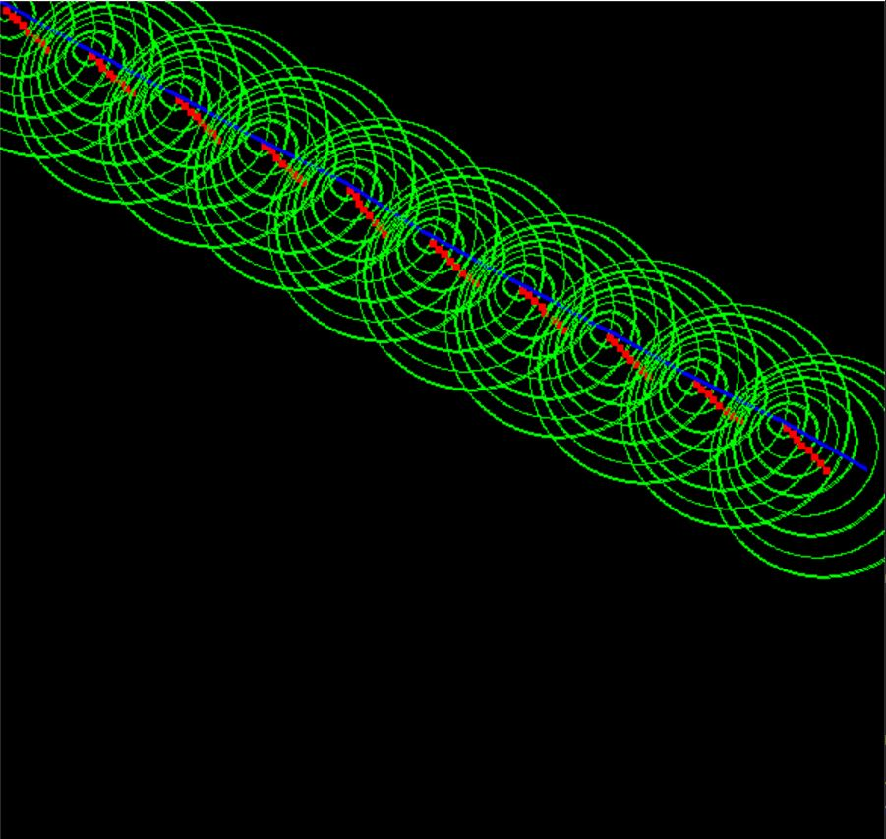

**Figure 1: Robot Trajectory**